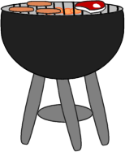Taller 2, activity 2: Escribe 3 palabras en cada categoría!

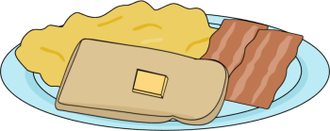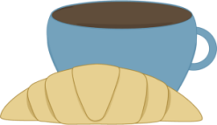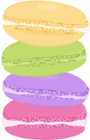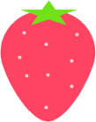

Snacks

Vitamins

Dairy products

Activities in the kitchen

Things in the cupboard

Things on the table

Red fruits

Green vegetables

Desserts

Main plates

Cereals

Food you can keep frozen

Food you can cut

Food you can drink

Food you can fry